  - Self Insurers of South Australia
  - Injury Prevention and Injury Management
  - General Meetings
  - Friday 20th October 2017
  - Venue: Sage Hotel, 208 South Terrace, ADELAIDE
  - 8.30am to 1.15pm
  - Guest Speaker: Dr James Hundertmark
  - Topic: Drugs & Alcohol in the Workplace

  - Guest Speaker: Dr John Edwards
  - Edwards Toxicology
  - Topic: The detection of use of illegal drugs in the workplace

  - SEATING IS LIMITED
  - YOU MUST LOGIN AS A MEMBER AND REGISTER ONLINE
  - WWW.SISA.NET.AU
  - Any queries please email: gail@sisa.net.au
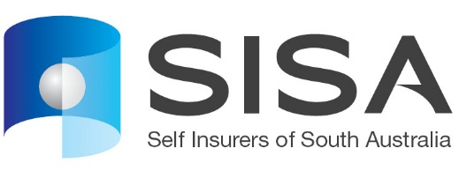

  - SISA thanks the Sponsor

